Equity PayPal Withdrawal API Design Specification Document

Version: Draft

Feb, 2018

Contact Person

Name | Geoffrey Wambugu
Email | Geoffrey.kamau@equitybank.co.ke

Contents
1.0 Overview 3
1.1 Profile management 3
1.2 Account Linkage 3
1.3 Balance 3
This API query PayPal account Balance using the stored permissions. 3
1.4 Withdrawal 3
1.5 Top-up 3
2.0 API Fields Description 3
2.1 Profile Creation 3
2.1 Fetch Customer Profile 4
2.2 Account Linking 5
2.3 Retrieve Accounts Linked 6
2.3 Withdrawal 6
2.4 Top Up 7
3.0 API Calls Flows 8
3.1 Bank account Linking 8
3.2 Mpesa Wallet Linking 9
3.3 Get Balance 10
3.4 Withdrawal 11
3.5 Top Up 12
4.0 Sample payloads 12
4.1 Create Profile 12
5.0 Security 13
5.1 Signature 13
6.0 Response Codes and Error Codes 13
6.1 Response Codes 13
6.2 Error Codes 13

1.0 Overview

This document covers back end APIs consumed by Front End applications for the PayPal Bank Withdrawal service. In additional to providing the functional requirements these APIs provide centralized PayPal’s permissions and consolidate APIs. The APIs are grouped into following subjects:
- Profile management
- Account Linkage
- Withdrawal and Balance
- TopUp

1.1 Profile management
These set of APIs covers Customer profile creation and storing, updating and retrieval of customer data. It also covers and user access authentication; - this API is primarily used by application/s that do not have Database access. A prerequisite to calling Withdrawal and Top Up is fetching linked accounts. This query is provided by getAccountByNationaID API.

1.2 Account Linkage
This API links Bank Account or Mpesa Wallet to PayPal account. It creates and store backend permissions. These permissions are used to initiate Balance and Withdrawal calls to PayPal, these permissions reusable to different applications.

1.3 Balance

This API query PayPal account Balance using the stored permissions.

1.4 Withdrawal
This API moves funds from user/customer PayPal account to Bank account or Mpesa Wallet. The value date is after 72 hours.

1.5 Top-up
This API moves funds from user/customer Bank/Mpesa account to PayPal Wallet or to be opened PayPal Wallet. It’s a two part transaction: - Get funds from Customer account and transfer funds from Equity PayPal omnibus account to any PayPal customer account.

2.0 API Fields Description

2.1 Profile Creation
This API is a REST API that supports POST method.
Endpoint URL:
http://{HOST}:{PORT}/signup/custos-profile

The host is 10.14.2.7 and port is 20000.

The inputs fields are wrapped in JSON object.
Parameters/Fields:

Table: 1a
Type | Name | Required | Remarks
Integer | Id | No | Auto generated
String | emailaddress | Yes
String | nationalId | Yes
String | passport | Yes
String | mobilephonenumber | Yes
String | bankAccountnumber | No
String | firstname | Yes
String | middlename | Yes
String | Lastname | Yes
String | postalcode | No
String | profession | No
String | citizenshipCountrycode | Yes
String | currentCountrycode | Yes
Date | dateofbirth | Yes
String | registrationType | No
Short | performExtraVetting | No
String | taxid | No
String | occupation | No
String | addressline1 | Yes
String | addressline2 | Yes
String | addressline3 | Yes
Date | dateCreated | No
Date | dateModified | No
String | status | Yes | default to 1
Integer | version | Yes | default to 2

The response:
A JSON object with fields in table 1a will be returned on condition if the response is success. Otherwise for fail a null is returned. The following headers in Table 1b
Table: 1b
Type | Name | Remarks
String | ERROR_CODE | Present in case the request failed
String | RESPONSE_CODE
String | RESPONSE_DESC

2.1 Fetch Customer Profile
This is a REST API and supports GET method.
Endpoint URL:
http://{HOST}:{PORT}/ppal/custos-profile/{id}

The host is 10.14.2.7 and port is 20000.

The inputs field are encoded in URL
Parameters/Fields:
Type | Name | Required | Remarks
Integer | Id | yes | Row ID

Response:
Returns a JSON Object with fields in Table 1a and Table 1b.

2.2 Account Linking
This is a REST API and supports POST method.
Endpoint URL:
http://{HOST}:{PORT}/rest-api/accounts/link

The host is 10.14.2.7 and port is 20000.

The inputs fields are wrapped in JSON object. The Inputs fields are in Table 1c and Table 1d
Parameters/Fields:
Table 1c
Type | Name | Required | Remarks
String | nationalId | yes
String | Emailaddress | Yes
String | nationalId | Yes
String | registrationType | Yes
String | Mobilephonenumber | Yes
String | bankAccountnumber | No
String | currencyCode | Yes
String | Firstname | Yes
String | Middlename | Yes
String | Lastname | Yes
String | citizenshipCountrycode | No
String | currentCountrycode | No

The following HTTPS Headers are required:
Table 1d
Type | Name | Required | Remarks
String | Channel | yes | The Application sending the request
String | Xcheck | Yes | Signature

Response:
A JSON object with following fields is returned
Table 1e
Type | Name | Required | Remarks
String | responseCode | yes | 00 for success
String | errorCode | Yes | Present if error is returned
String | errorDesc |  | Error description
String | popupURL |  | Returned if response is success

2.3 Retrieve Accounts Linked
This is a REST API and supports GET method.
Endpoint URL:
http://{HOST}:{PORT}/rest-api/accounts/customerByNationalId/{customerNationalId}

The host is 10.14.2.7 and port is 20000.

The inputs fields are encoded in URL and HTTP headers.
Input Fields in URL:

Type | Name | Required | Remarks
String | nationalId | yes

HTTP headers refers to table 1d

Response:
The response is a list JSON objects with the following fields:
Type | Name | Required | Remarks
Integer | id |  | Row ID
String | accountID |  | PayPal email
String | bankAccount |  | Bank account Number
String | paypalBalance | optional | Present in some response
String | paypalBalanceCurrency | optional | Present in some response
String | trackingNumber | optional | Present in some response
String | paypalTranId | optional | Present in some response
String | memo | optional | Free text

2.3 Withdrawal
This is a REST API and supports POST method.
Endpoint URL:
http://{HOST}:{PORT}/rest-api/accounts/withdrawal/{id}/{amount}

The host is 10.14.2.7 and port is 20000.

Input fields are encoded in URL and HTTP headers.
Input Fields in URL:

Type | Name | Required | Remarks
Integer | id | Yes | Holds Row ID
Float | amount | yes
String | memo | yes | Free text

HTTP headers refers to table 1d

Response:
The response is a list JSON objects with the following fields:
Type | Name | Required | Remarks
Integer | id |  | Row ID
String | accountID |  | PayPal email
String | bankAccount |  | Bank account Number
String | paypalBalance | optional | Present in some response
String | paypalBalanceCurrency | optional | Present in some response
String | trackingNumber | optional | Present in some response
String | paypalTranId | optional | Present in some response
String | memo | optional | Free text

2.4 Top Up
This is a REST API and supports POST method.
Endpoint URL:
http://{HOST}:{PORT}/rest-api/accounts/topup/{id}/{amount}/{memo}

The host is 10.14.2.7 and port is 20000.

Input fields are encoded in URL and HTTP headers.
Input Fields in URL:

Type | Name | Required | Remarks
Integer | id |  | Row ID
String | accountID |  | PayPal email
String | bankAccount |  | Bank account Number
String | paypalBalance | optional | Present in some response
String | paypalBalanceCurrency | optional | Present in some response
String | trackingNumber | optional | Present in some response
String | paypalTranId | optional | Present in some response
String | memo | optional | Free text

HTTP headers refers to table 1d

2.5 Account Balance
This is a REST API and supports GET method.
Endpoint URL:
http://{HOST}:{PORT}/rest-api/accounts/balance/{id}
Request Fields
Type | Name | Required | Remarks
Integer | id | Y | Account Row ID

Response:
The response is a JSON object with the following fields:
Type | Name | Required | Remarks
Integer | id |  | Row ID
String | accountID |  | PayPal email
String | bankAccount |  | Bank account Number Linked
String | paypalBalance
String | paypalBalanceCurrency
String | trackingNumber | optional | Present in some response
String | paypalTranId | optional | Present in some response
String | memo | optional | Free text

2.6 Transaction History
This is a REST API and supports GET method.
Endpoint URL:
http://{HOST}:{PORT}/rest-api/transaction/history/{accountId}/{offset}/{pagesize}
Request Fields
Type | Name | Required | Remarks
Integer | accountId | Y | Account Row ID
Integer | offset | Y | Page number
Integer | pagesize | Y | Number of records in the page

Response Fields
Type | Name | Required | Remarks
Integer | accountId | Y | Account Row ID
String | Tran Date | Y
String | bankTransactionID | Y
String | payPalTransactionID | Y
String | amount | Y
String | Value Date
String | Status | Y

The inputs fields are wrapped in JSON object. The Inputs fields are in Table 1c and Table 1d
Parameters/Fields:

3.0 API Calls Flows

3.1 Bank account Linking
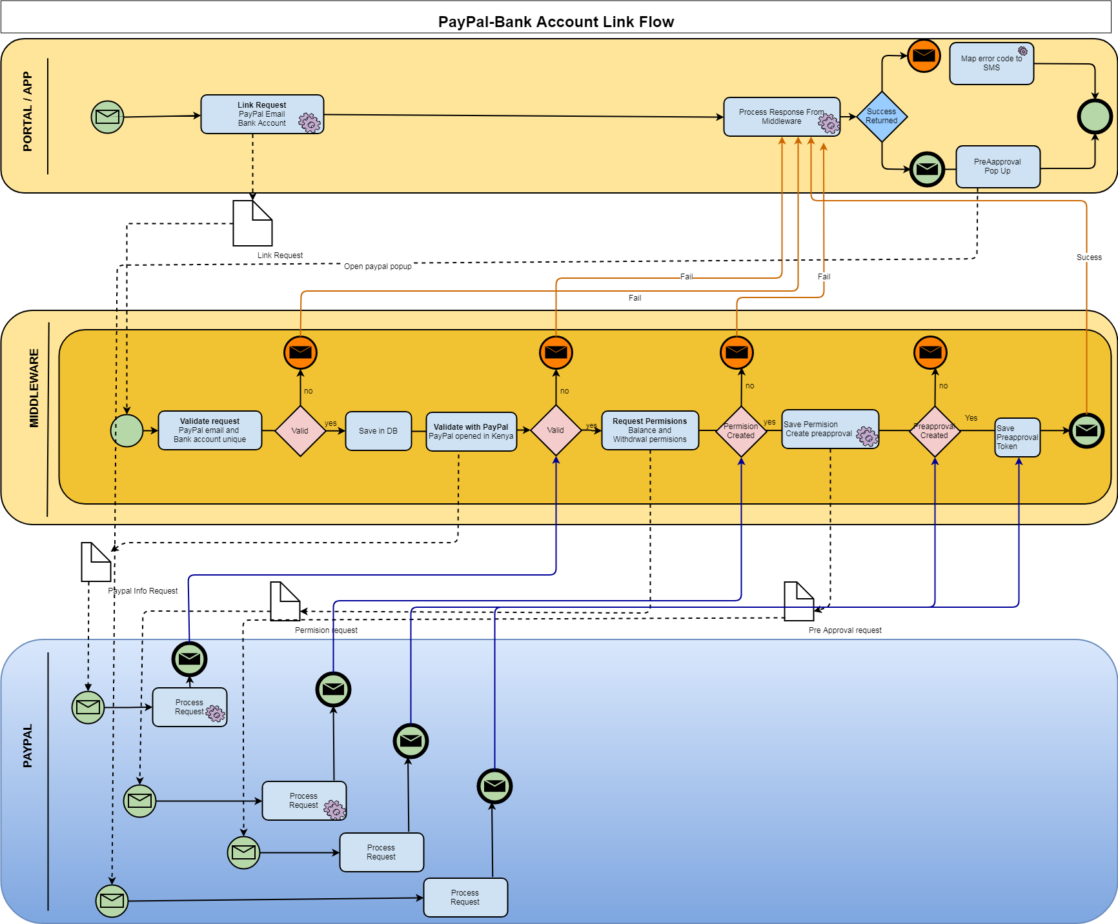

3.2 Mpesa Wallet Linking
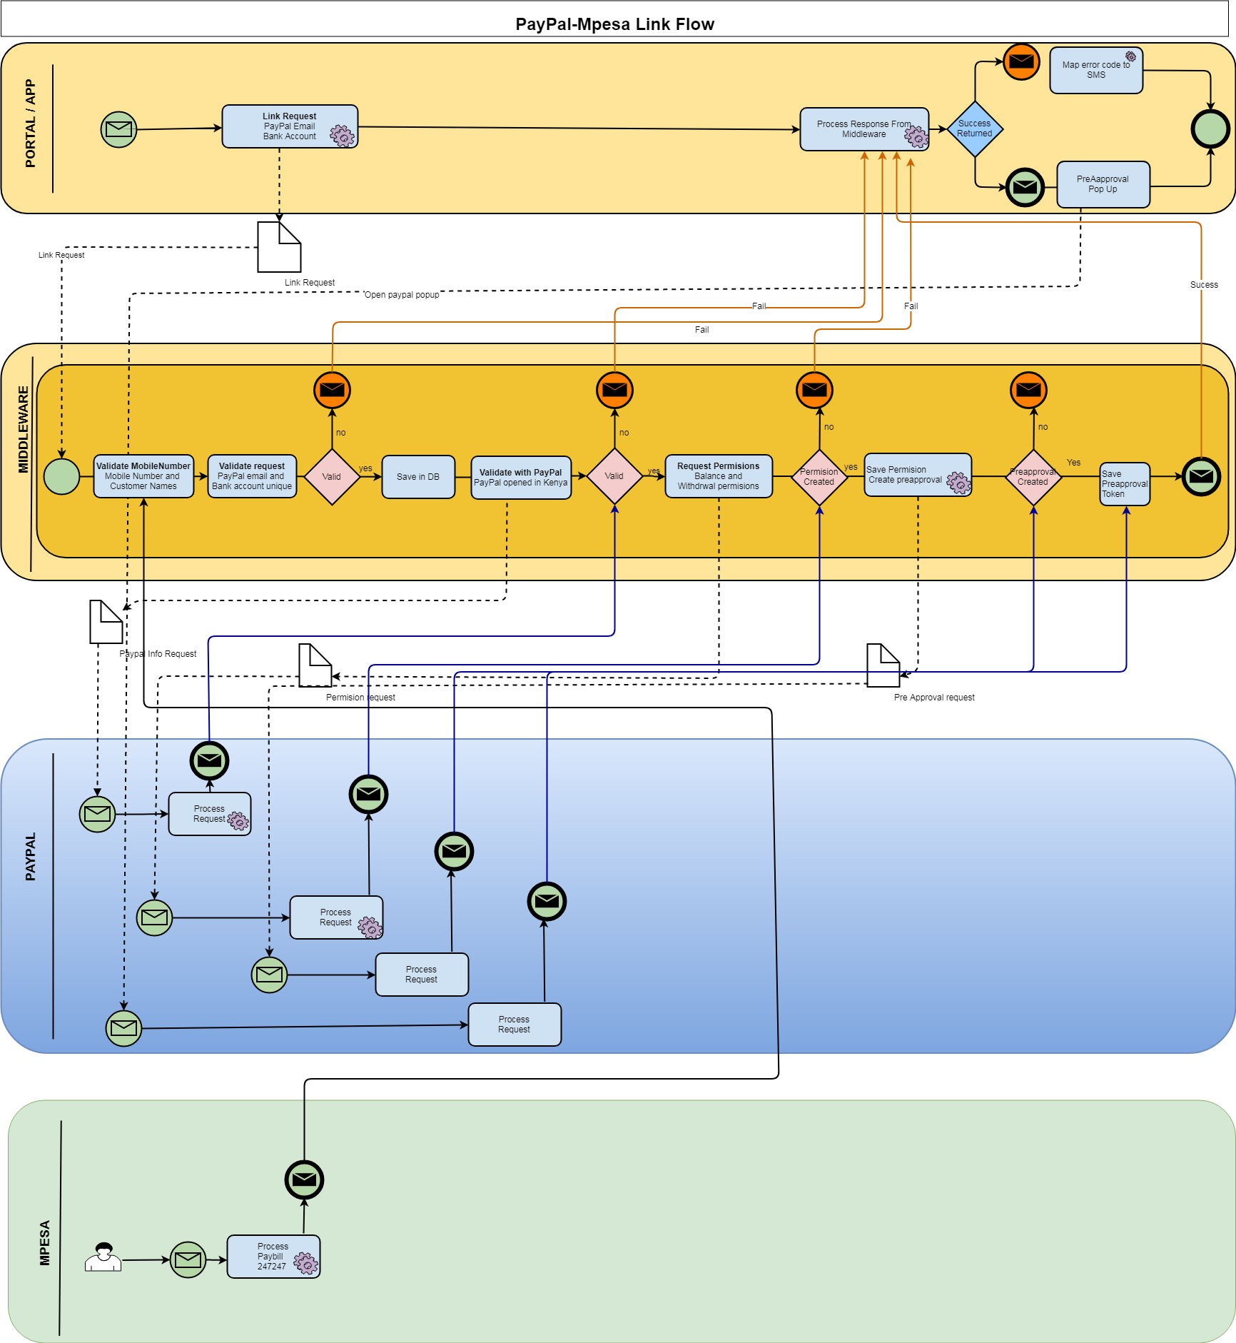

3.3 Get Balance
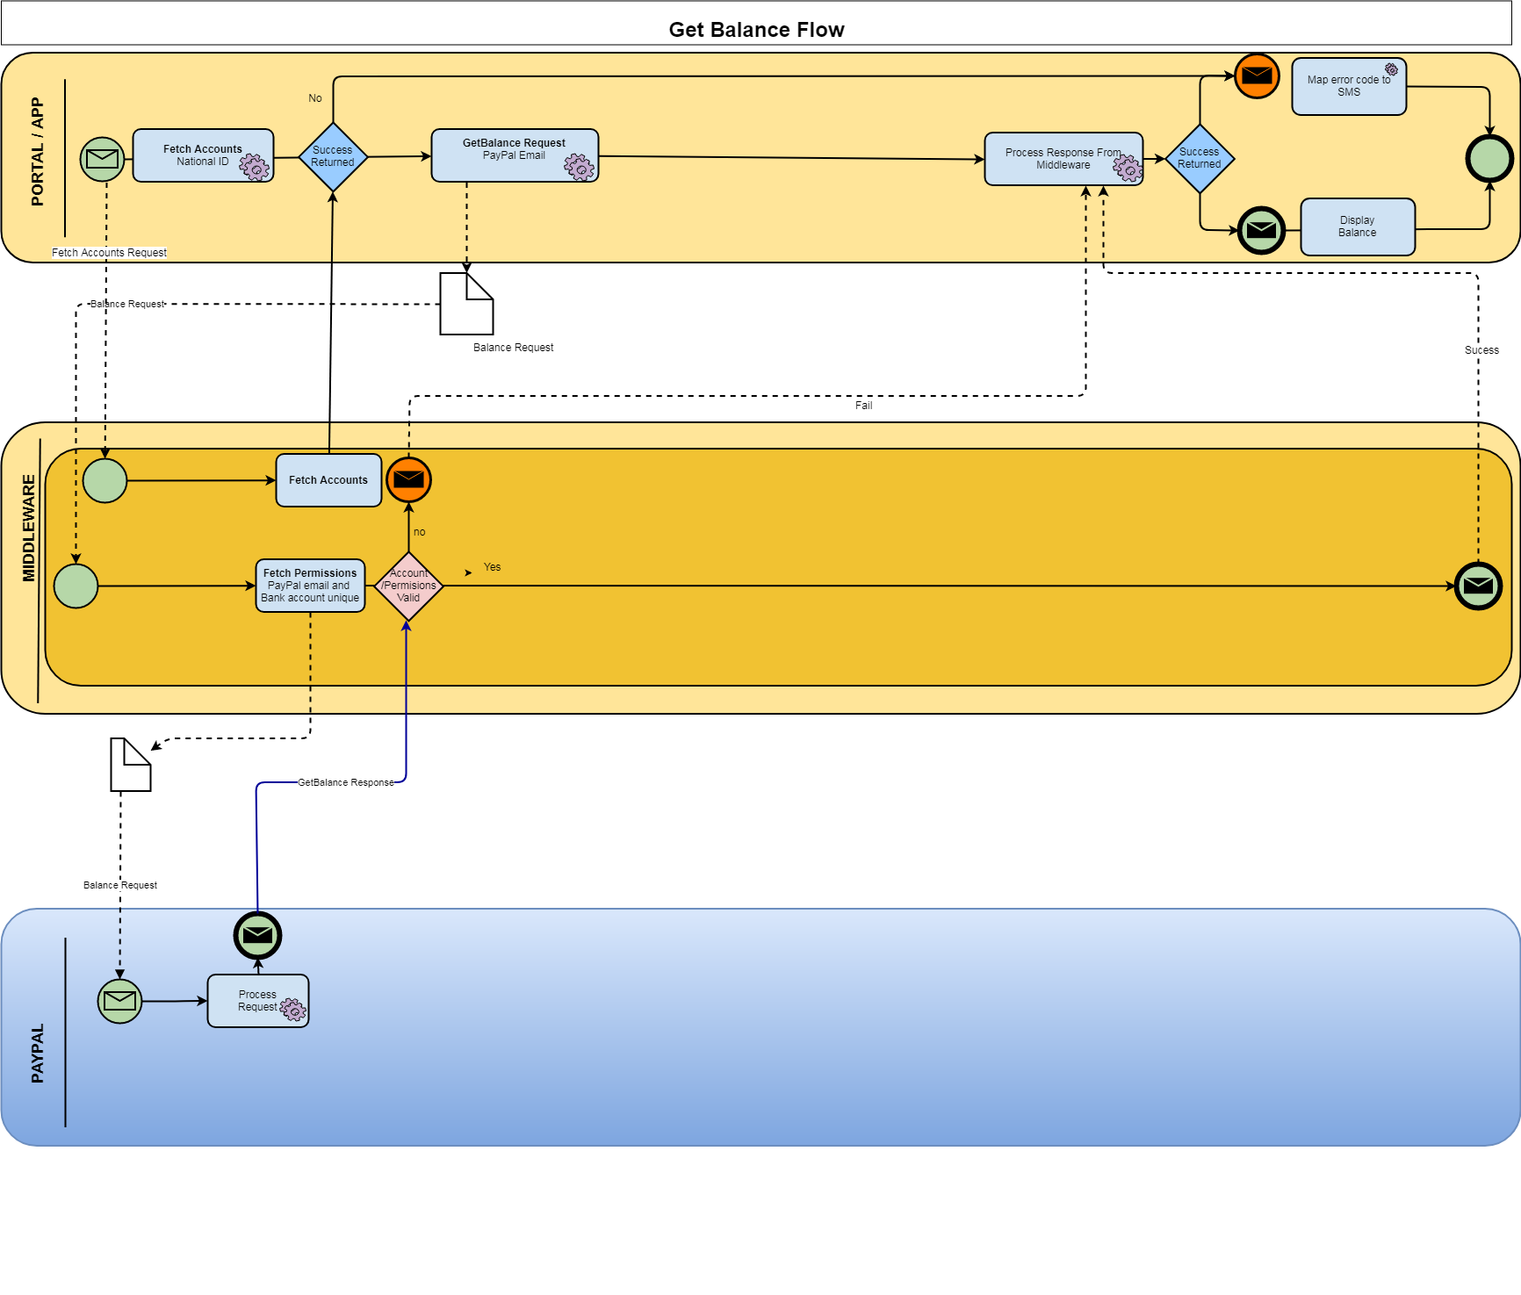

3.4 Withdrawal
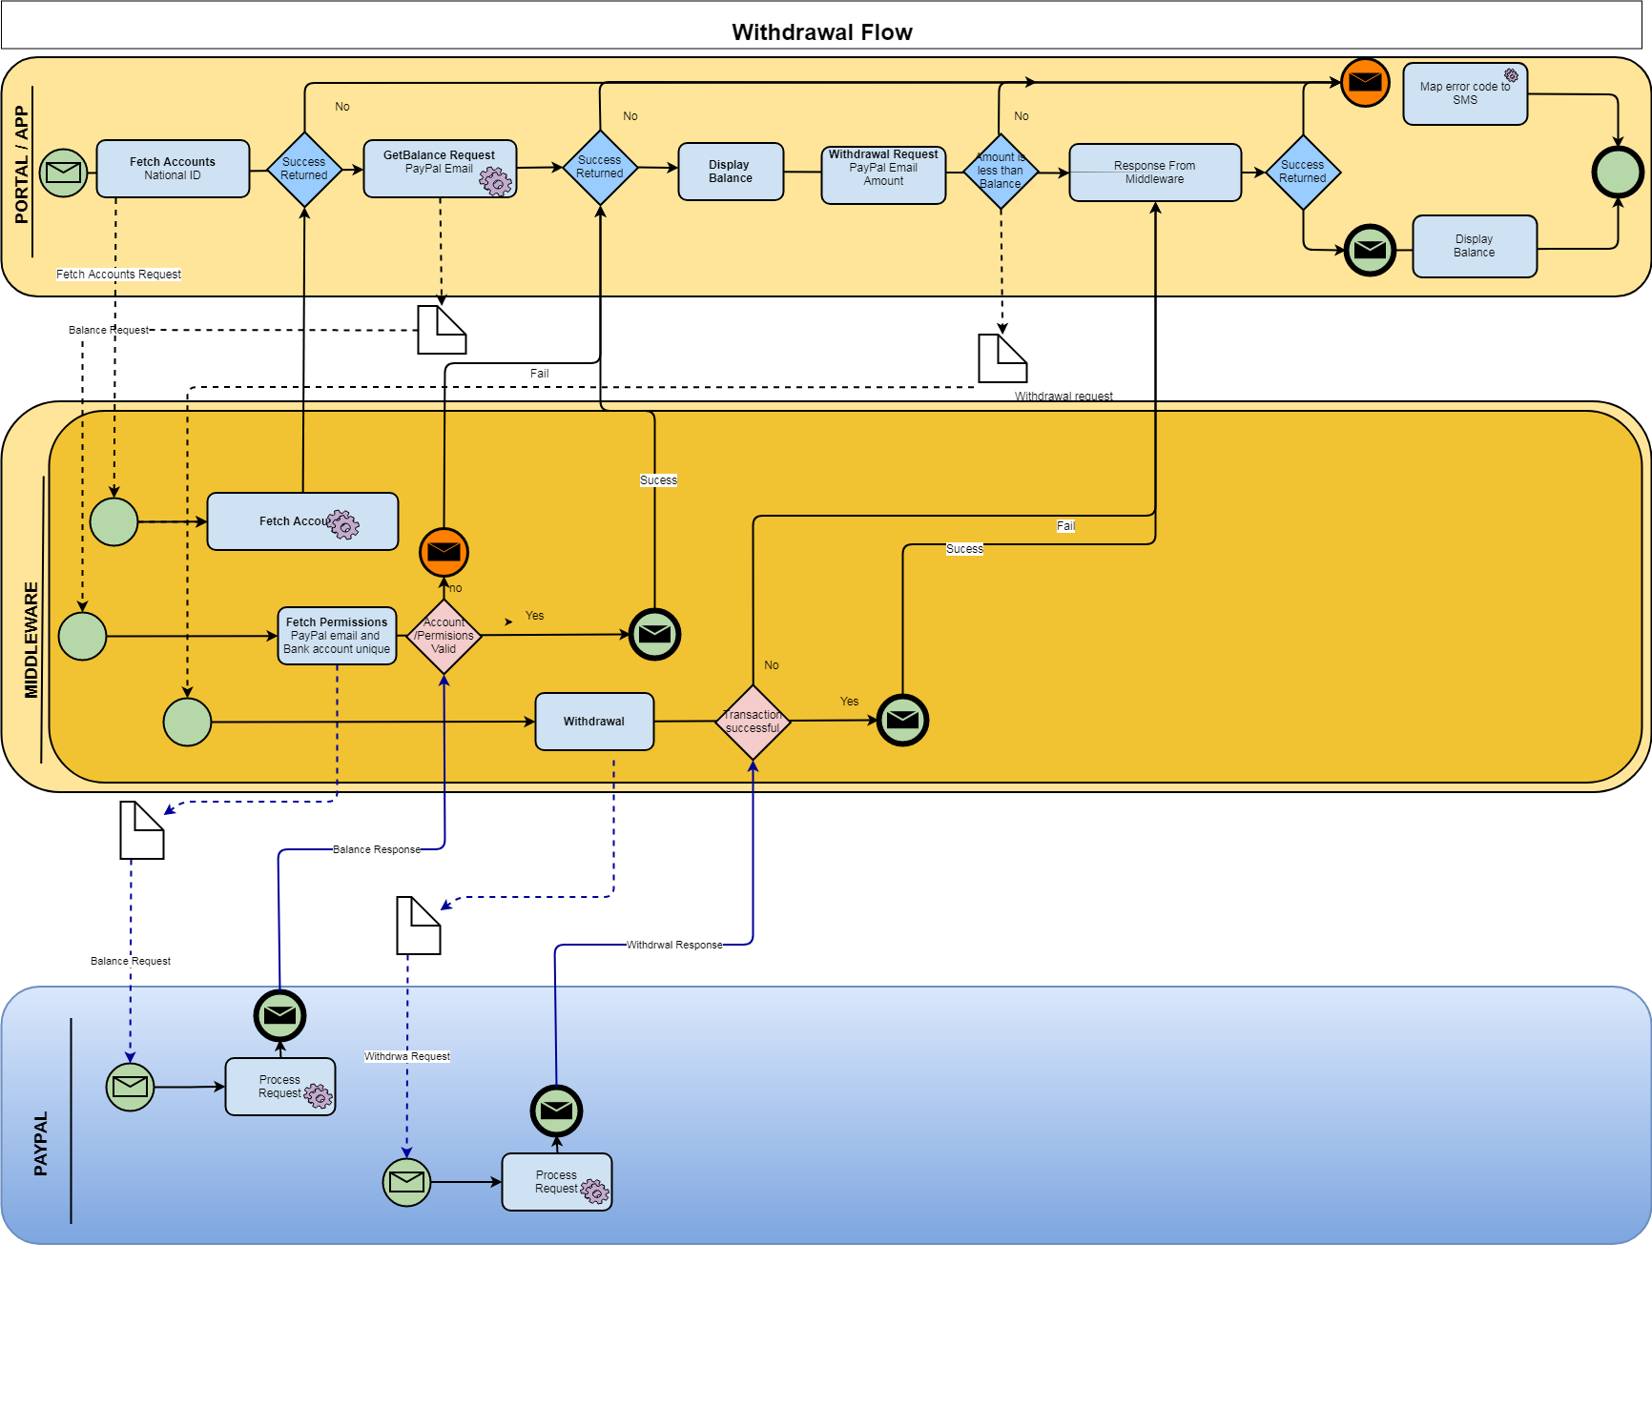

3.5 Top Up
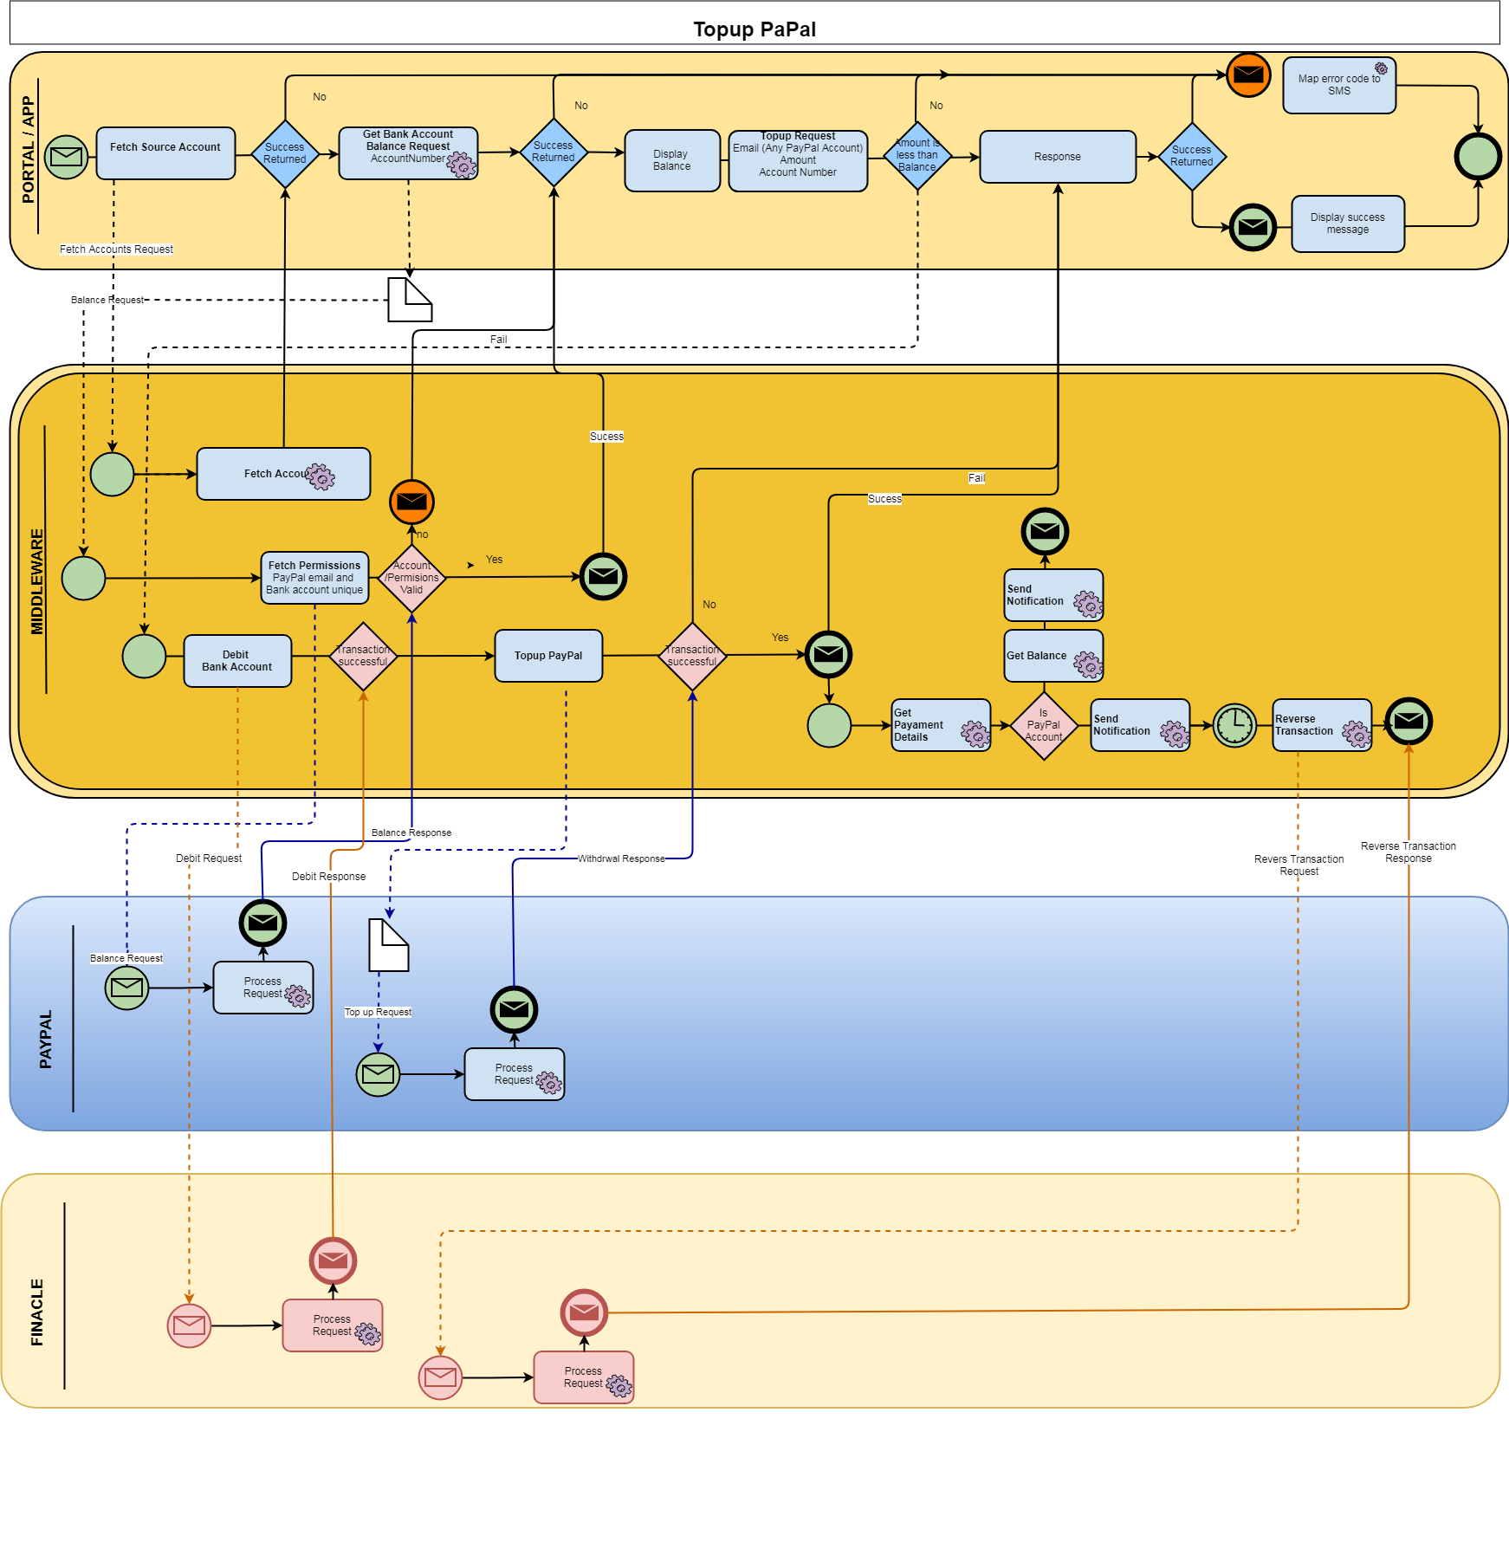

4.0 Sample payloads

4.1 Create Profile
{"emailaddress":"wambugu@gamil.com","nationalId":"22455778","passport":null,"mobilephonenumber":"415555","bankAccountnumber":"0000111222","firstname":"Geoff","middlename":null,"lastname":"Wambugu","postalcode":"254","profession":"IT","citizenshipCountrycode":"KE","currentCountrycode":"US","dateofbirth":1440720000000,"registrationType":null,"performExtraVetting":0,"taxid":"100","occupation":"IT","addressline1":null,"addressline2":null,"addressline3":null,"dateCreated":null,"dateModified":null,"status":null,"version":null,"password":"XXX ","q1":null,"q2":null,"q3":null,"q1a":null,"q2a":null,"q3a":null}

5.0 Security

5.1 Signature
The security of the API is enforced with the use of digital signature. The fields to be signed are described in each API. After concatenating the fields the resulting text is signed with private key and resulting binary data encoded with base 64. This is supplied in xcheck field.
Fields to be concatenated:
Balance API : channel+id
Withdrawal: channel + id+ amount
Get Linked Account: channel + national ID
Get Profile: channel + national ID
Topup: channel + id+ amount
Link Account : channel +Emailaddress+ NationalId +Mobilephonenumber+BankAccountnumber

6.0 Response Codes and Error Codes

6.1 Response Codes

RESPONSE CODE | DESC
200 | success
403 | Fail

6.2 Error Codes

ERROR CODE | DESC
-3 | Duplicate Error
-2 | Signature failure
20 | Permissions failed
21 | Preapproval failed

